* 1. **OBJECTIVE:** To Install XAMPP Stack Server.

**RESOURCES:**

XAMPP Stack Software, 1GB RAM, Hard Disk 80 GB.

* 1. **PROCEDURE:**

1. Run the XAMPP setup software.
2. In the next Screen, Select the path if required and then click on the Next Button.

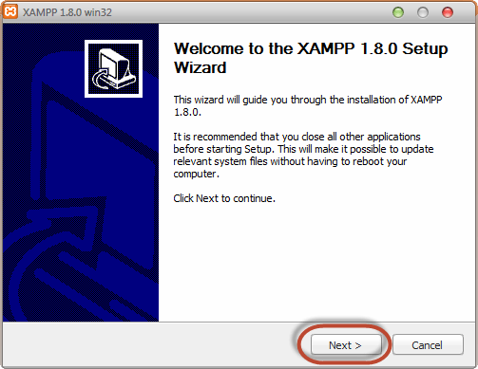

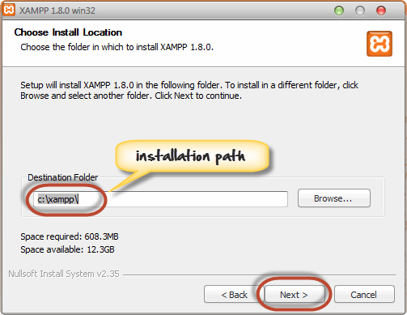

1. In the next screen select Apache and MySQL. You may optionally select FileZilla (FTP Client) if needed. Click Install.

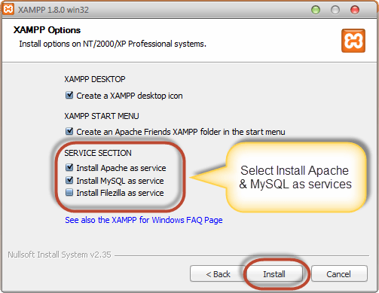

1. On successful completion of installation, the following window will appear.

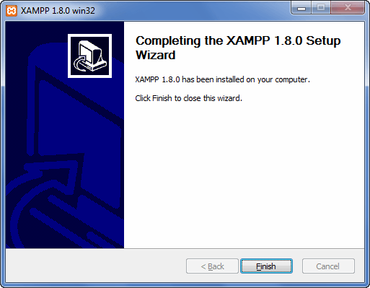

1. Click on Finish button.
   1. **INPUT AND OUTPUT:**

